AWS PROJECT SESSIONS
Project Write-Up

01 | Project Overview

Project name | Project type
Mobile Phone App – Currency Converter | Mobile Phone App creation
Prepared by | Date
Stuart Allan | August 2026

One-line project summary
Create an mobile phone app to allow users to convert from one currency to another either with or without internet access

02 | Problem Statement

Who is this for?
People travelling to foreign countries (outside the area where you can use data roaming).

What problem exists today?
Current currency converter apps require internet access to work as they only use on-line currency exchange rates.
In areas where there is no internet connection, or countries where data roaming costs a small fortune, converting from one currency into another can be difficult or expensive.

What does success look like?
People will be able to convert from any currency into any other currency without the need for the internet.

03 | Proposed Solution

Solution overview
A mobile phone app will be coded and tested using AWS services before being hosted on the app stores.

Why cloud? Why AWS?
Cloud based is the correct solution as there will be minimal costs involved (possible zero under the free tier subscription).

Key features delivered
Download the app from the app stores.
Create an account personal to them.
Convert from one currency to another either by using an online conversion rate, or by using a user input conversion rate – off-line mode.
The ability to subscribe to other currencies that are not featured in the free version.

Version 1 – Simple index page with conversion from one currency to another, and an add currency page with the ability to add another currency to the lists for a small cost.
Version 2 – Add in Cognito to authenticate sign in and sign up and DynamoDB to record any purchases.
Version 3 – Add contact page.
Version 4 – Add ability to change into a selection of foreign languages.

04 | Architecture Diagram

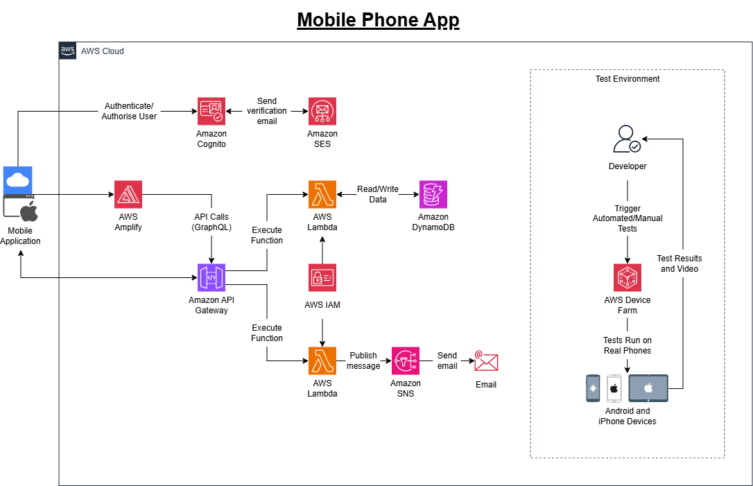

05 | AWS Services Used

Service | What it does in this project | Why chosen over alternatives
COMPUTE
Lambda | Processes contact form and purchase details
STORAGE
S3 | Stores the CloudFormation templates
NETWORKING & DELIVERY
API Gateway | The front door for Lambda
DATABASE
DynamoDB | Lists the user ID and currency(ies) bought
SECURITY & IAM
IAM | Gives Lambda the required permissions to call DynamoDB and SNS via a managed baseline policy and an inline policy as an Execution Role
Cognito | Provides a secure user directory to manage sign-up, sign-in and profile data
FRONT-END WEB AND MOBILE SERVICES
Amplify | Hosts and deploys the web app with automated Git-based updates
Device Farm | Allows testing of the mobile app on actual iOS, Android, and Fire OS devices
NOTIFICATIONS
SNS | Sends emails from the contact form
SES | Used by Cognito to send a verification email to users during sign-up process

06 | Application Flow

Flow 1 — Opening the application for the first time
- Step 1: Directed to the “Sign In or Register” page.
- Step 2: Click Register.
- Step 3: Enter email address and a password.
- Step 4: Click the “Create Account” button. This takes you to the “Verify Email” page.
- Step 5: Enter the email address and the 6 digit verification code from the sent email.
- Step 6: Click the “Verify Account” button.
- Step 7: This takes you back to the home page.

Flow 2 — Opening the application
- Step 1: Directed to the “Sign In or Register” page.
- Step 2: Click Sign In.
- Step 3: Enter email address and a password.
- Step 4: Click the “Sign In” button.
- Step 5: This takes you back to the home page.
Flow 3 — Converting one currency into another
- Step 1: Enter the amount you want to convert (usually in the foreign currency).
- Step 2: Change the “From Currency” into the currency you are using.
- Step 3: Change the “To Currency” into GBP – British Pounds (should be the default).
- Step 4: Press the “Switch Currencies” button if they are already entered, but the wrong way round.
- Step 5: Press the “Fetch Live Exchange Rate” button (if online) to receive the current exchange rate for the currency you are using.
- Step 6: If offline (or prefer to use the exchange rate you bought the currency at), enter the value in the “Exchange rate currency bought at” box.
- Step 7: Read off the converted amount from the light blue box.

Flow 4 — Adding an additional currency
- Step 1: Click the “Add an Additional Currency” button at the bottom of the screen.
- Step 2: Select the World Currency from the drop-down menu.
- Step 3: Click wither the “PayPal” button to pay via PayPal or the “Debit or Credit Card” button to pay by Credit or Debit Card.
- Step 4: Once payment has been completed, you are automatically redirected back to the home page and the “bought” currency appears in the “From Currency” and “To Currency” menus

Flow 5 — Visitor submits contact form
- Step 1: Visitor fills in the form and clicks Send
- Step 2: Browser sends a POST request to the API Gateway endpoint
- Step 3: API Gateway triggers the contact form Lambda function
- Step 4: Lambda reads the form data and validates it
- Step 5: Lambda calls SNS to send an email to the site owner
- Step 6: Lambda returns a success response — browser shows confirmation

07 | Security

Security control | How it is implemented in this project | Status
IAM least privilege | Lambda execution role grants only DynamoDB read/write and SNS post — no other permissions. | Implemented
No hardcoded credentials | No AWS keys in code. Lambda uses IAM execution role. Table names in environment variables. | Implemented
CORS configured | API Gateway CORS allows requests only from the application domain, not all origins. | Implemented

Known limitations / not implemented in this version
Rate limiting on the contact form API is not implemented in this version.
A production deployment would add AWS WAF rules to prevent spam.

08 | Cost Estimate

Service | Usage assumption | Free Tier cost/month | Production cost/month
Lambda | 100 requests/month | £0.00 | £0.00
DynamoDB | 0.01GB storage | £0.00 | £0.00
SNS | 50 requests/month | £0.00 | £0.00
API Gateway | 100 requests/month | £0.00 | £0.00
Cognito | 50 MAUs | £0.00 | £0.00
Amplify | 100 build minutes/month | £0.00 | £0.00
S3 | 0 (used to store templates) | £0.00 | £0.00
SES | 15 emails per month | £0.00 | £0.00
ESTIMATED MONTHLY TOTAL |  | £0.00 | £0.00/month

09 | Next Steps & Future Improvements

Planned improvements for the next version
Add AWS WAF to protect the API from spam and abuse.

GitHub repository link | Live project URL
https://github.com/stuartallan1981/CurrencyConverter | https://www.stuart-allan.com/CurrencyConverterApp  /index.html
https://github.com/stuartallan1981/CurrencyConverter | Google Play App Store (Coming soon)

